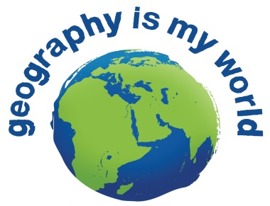

Fieldwork in geography
Use the information on pages 36 – 40 in Oxford Big Ideas Geography 10to answer the following questions.

What is the field to geographers?

What are secondary sources of information to a geographer?

What do you need to do to understand a landscape?

List the reasons that make field trips essential to geographers.

*

*

*

*

*

What is the aim of fieldwork?

All field work is activity based and inquiry based. Read the skills on page 36 and list them in the correct cell below.
Activity | Inquiry

If fieldwork takes place in many locations for a wide variety of reasons, what are the best locations to study?

Why?

What is the next most popular place to study?

Why?

Now list in your file the stages for conducting successful fieldwork 1 – 5. Please write a brief description for each.

